RRU9816 Demo Software User's Guidev1.0
1. Parameter interface operation 1
1.1 Open COM Port 1
1.2 Parameter Setting: 1
2. The Necessary Knowledge 2
2.1 EPCC1G2 tag memory 2
2.2 Data display (tag ID, passwords, memory data is display in 16 hexadecimal) 3
3. EPCC1-G2 Test 3
3.1 Query Tag EPC 3
3.2 Read Data, Write Data, Block Erase 4
3.3Revise the password 6
3.4 Write EPC 7
3.5 Lock Operation 7
3.6 Read Protection 8
3.7 EAS Alarm 9
3.8 Kill Tag（Permanently Kill） 10
3.9 Mask conditions 11
4. Buffer operation 12

1. Parameter interface operation

1.1 Open COM Port
Before use this demo, please install the USB serial port driver,.net framework.
Select Port
And baud rate (default) , click ,
If success , can see

1.2 Parameter Setting:

（1）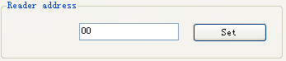 the new reader address to set. This address can't be 0xFF. If set 0xFF, reader will return error information.
（2）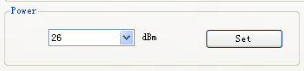 set and save power configuration.
（3）
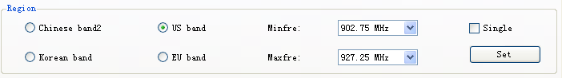 select the reader’s band, different band, the frequency is different.
（4） Set reader working Min Frequency and Max Frequency. In different places, the radio requires the rule to be different. Users can follow the local situation and choose to read more sensitive frequency range of the card. In single frequency point operation, only need to set two frequencies to the same value. In frequency hopping operation, only need to set two frequencies to the different value.
（5）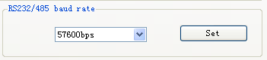 demo software start run, default use the baud rate 57600 to open COM port, reader power on, reader baud rate default is 57600. After change the baud rate, reader use the new baud rate until power off. Close port and open port, the baud rate no change. The demo software will use the new baud rate, until close the demo software.
（6）GPIO Operation
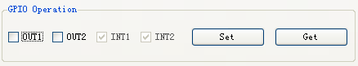Select need pins，click ，Can control the output state pins，Click ，can get output state pins.
（7）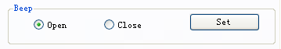，Set beep open or close
（8）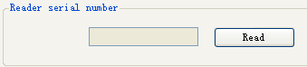，click can get reader’s serial number.
（9）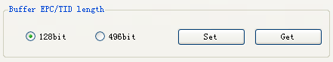，this function is used to get or set EPC/TID length on buffer tag.
（10），this function is used to restore default setting of reader.
（11），this function is used to get reader’s information.

2. The Necessary Knowledge

2.1 EPCC1G2 tag memory
Tag memory divided into four storage areas, each storage area can be made up of one or more memory words. The four storage areas:
EPC areas (EPC): Store the area of EPC number, this module stipulates it can store 15 word EPC number. Can read and can write.
TID areas (TID): Store ID number established by the tag production firm. There are 4 words and 8 words two kinds of ID numbers at present. Can read and not can write.
User areas (User): This area of different manufacturers is different. There is no user area in G2 tag of Inpinj Company. There are 28 words in Philips Company. Can read and can write.
Password areas (Password): The first two words is kill password, the last two words is access password. Can read and can write.
Can write protect in four storage areas. It means this area is never writeable or not writeable under the non-safe state; only password area can set unreadable.

2.2 Data display (tag ID, passwords, memory data is display in 16 hexadecimal)
Display in Hex, then 11 is first byte, 22 is second byte, and 1122 is first word.
Total 8 bytes, in other words, total 4 words.

3. EPCC1-G2 Test

3.1 Query Tag EPC
（1）Select EPC or TID to read, like
Select other condition
Note: about Q, S choice, a single tag or less number must be S0, a lot of tag queries using S1 or S2, S3. 2^{Q} equal tag number is better. If it is a single query effect must use S0

（2）Click 
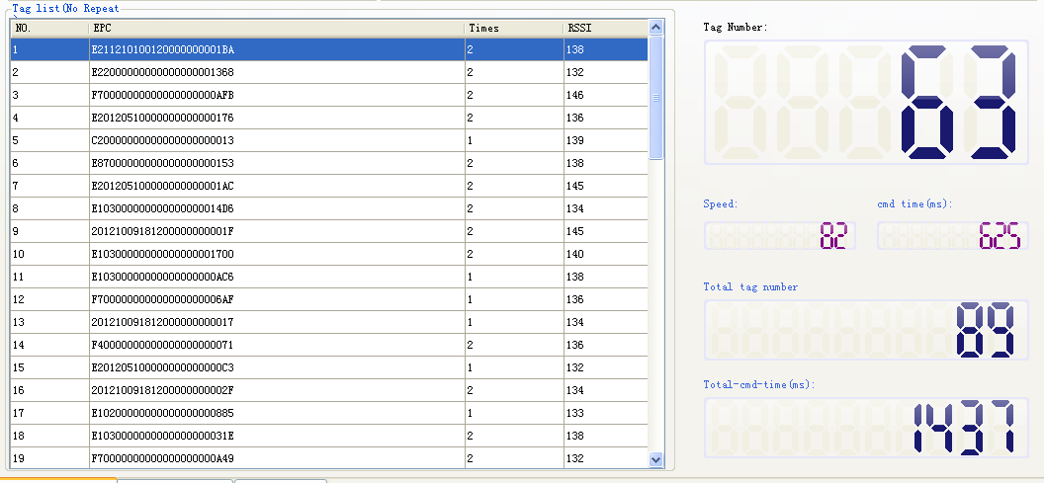

3.2 Read Data, Write Data, Block Erase
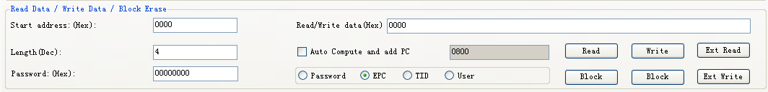
<1> Select one tag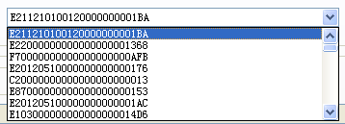then click
,check
Select memory to be operation
(1) Read data operation
<1> Input data like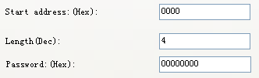
Start address: 0x00 stand in start to read data from first word in the designated storage area, 0x01 stand in start to read data from second word in the designated storage area, and so on.
Read the length: Number of the word to be read. It read 120 words at most. Can not set 0 or 120, otherwise, return the parameter error information.
Access password: From left to right it is the former high-word, low word in the access password. If operation don’t need access password, it can be the arbitrary value, but can't lack.
<2> Clickcan see
is used to read large memory of tag.
(2) Write data operation
<1> Input Write data word address
and Password
Start address: 0x00, the first word of data (from left) is written in address 0x00 of the designated storage area, and so on.
<2>Input data what you want to write like
<3> Clickcan see
Note: write data can be used to change the EPC number (the method is as follows)

<1> Choose memory ,and
select
<3>Write EPC number
（EPC memory Address of tag is 2）
<4> Clickcan see
Then query tag EPC, can see
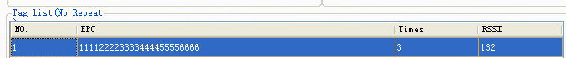
is used to Write large memory of tag.

(3) Input erase data address and length
Start address: 0x00, the first word of data (from left) is written in address 0x00 of the designated storage area, and so on.
The difference from write operation: Needn't fill in the data.
<4> Click can see
then the data will be set to 0
(4) Write block operation
<1> Input Write data word address
and Password
Start address: 0x00, the first word of data (from left) is written in address 0x00 of the designated storage area, and so on.
<2>Input data what you want to write like
<3> Clickcan see

3.3Revise the password

(1) Select one tag
Select memory to be operation

(2) Write access password
Access password: default is 00000000, if you have change to others, you should input right values.
(3) Revise the access password 12345678: Write

Click.
(4) Revise the kill password 12345678: Write
Click
(5) If succeed, we can see

3.4 Write EPC
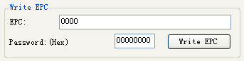
(1) Write access password (If EPC area of the tag has not set password protection, we can write 8 data arbitrarily)
(2) Write EPC.
(3) Click . (Random write one tag in the effective range of antenna)
When there are many or EPC pieces of tag in the effective range of antenna, and the access password of one tag is the same as you entered, or EPC area of tag set no password protection, click at a time, random write EPC number of one tag in the effective range of antenna.

3.5 Lock Operation
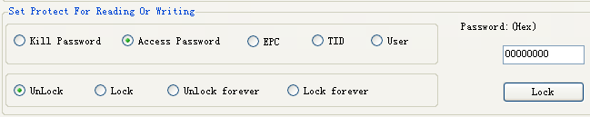
(1) Select one tag
(2) select memory
to be operation
- select protect type

- Input access password Any storage area in no password protection status still must write the correct access password.(password can not be zero).
- Clickthen, the option is over.

3.6 Read Protection
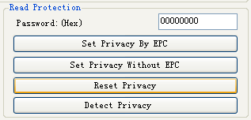
Select one tag
(1) Set Single Tag Read Protection
According to EPC number of the tag, setting read protection, make tag unable to be read and written by any order, even if query the tag, it is unable to get EPC number of the tag. Only NXP UCODE EPC G2X tags valid.

(2) Set Single Tag Read Protection without EPC
can set tag read protection in the effective range of antenna
The difference from : When there are several tag in the effective range of antenna, reader don’t know the tag which the order operate.
If operate several tags, then the access password of the tag had better be the same. Only NXP UCODE EPC G2X tags valid.
(3) Reset Single Tag Read Protection without EPC
Use for reset the tag read protection.
Only put a tag in the effective range of antenna. Only NXP UCODE EPC G2X tags valid.
Comments: If tag does not support the read protection setting, it must be unprotected.
(4) Detect Single Tag Read Protection without EPC
<1> Click
Can't detect tag whether it support read protection order, can only detect single tag whether it is protected. If tag does not support the read protection setting, it must be unprotected.
Make sure that there is single tag in the effective range of antenna. Only NXP UCODE EPC G2X tags valid.

3.7 EAS Alarm
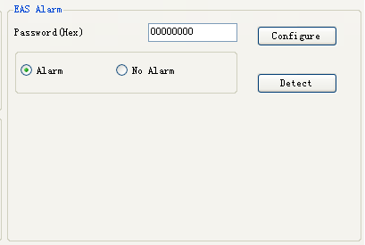
Select one tag

(1) Alarm setting
<3> Choose alarm 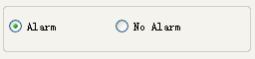
Set or reset the EAS status bit of tag. Only NXP UCODE EPC G2X tags valid.
(2) Check alarm without EPC and access password
<1> Click check alarm
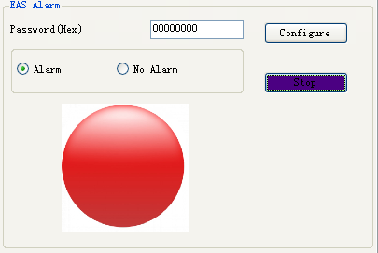
Check the EAS alarm of tag. Only NXP UCODE EPC G2X tags valid.
<2> EAS alarm:

No EAS alarm:

3.8 Kill Tag（Permanently Kill）

(1) Select one tag

(2) Write 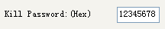
Kill password can not be the whole 0. Otherwise, the tag can not be killed, and the tag return response with parameter error.
(3) Click ,if success, the tag is killed.

3.9 Mask conditions
check enable
Only check enable can do mask operation。
For example, EPC mask：
Choose EPC area：
Only the first byte of tag’s EPC is DA could response.
For example, TID mask：
<1>Query TID 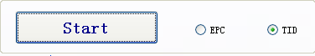
Can see TID
<Mask condition>
For example change EPC :
<2> select
and

<3> Write 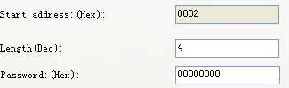（EPC memory Address of tag Is 2）
<4> Click can see

4. Buffer operation
(1) Select EPC/TID query. For example: EPC

This demo is used Q=4,S=1,Target A to inventory tag, if there are some tag
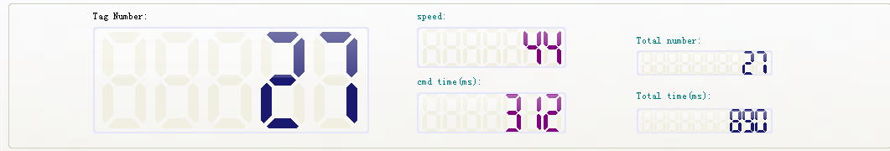
(2) is used to read tag in the buffer, if there are tag
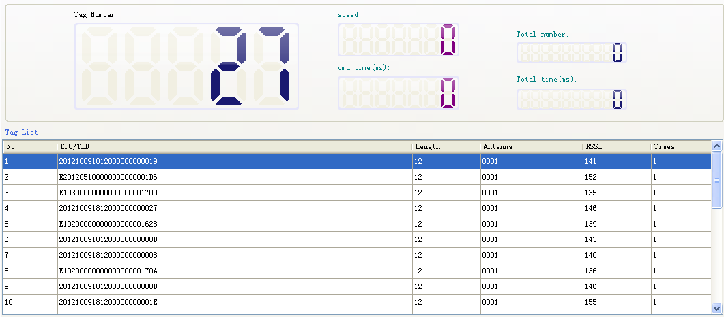
(3)  is used to clear tag information in the buffer.
(4)  is used to read out tag and clear tag in the buffer.
(5)  is used to get

